Kubernetes Task-4
- Deploy an application using a Deployment with 3 replicas and a rolling update strategy.
- Configure a Deployment with a Recreate strategy and observe the downtime.
- Update an existing Deployment and perform a rollback to the previous version.
- Modify a Deployment to add resource requests and limits for CPU and memory.
- Create a Deployment with MaxSurge and MaxUnavailable configurations.
- Set up a Deployment with a custom revision history limit.
- Pause a Deployment during an update, and then resume it.
- Create a pod using resource requests for memory and CPU, and observe how the scheduler assigns it to a node.
1.
Env is ready
Vi deployments.yaml
apiVersion: apps/v1
kind: Deployment
metadata:
name: firstdeployment
labels:
appname: testapp

spec:
replicas: 3
selector:
matchExpressions:
- key: env
operator: In
values:
- prod
template:
metadata:
name: firstpod
labels:
env: prod
spec:
containers:
- name: firstcontainer
image: nginx
env:
- name: myname

Kubectl create -f deployments.yaml
kubectl get pods
kubectl get deployments
kubectl rollout status deployments/firstdeployment

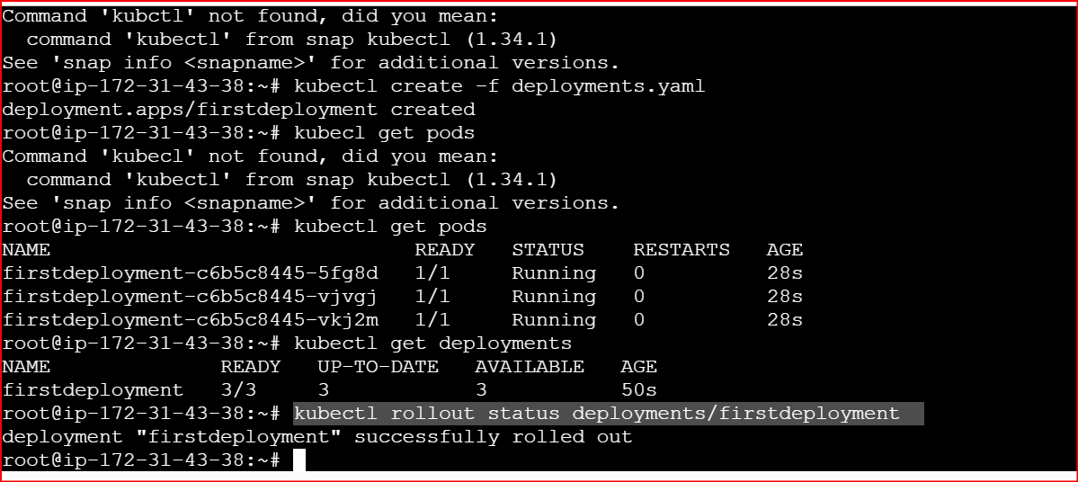

2.
YAML: nginx-recreate.yaml
apiVersion: apps/v1
kind: Deployment
metadata:
name: nginx-recreate
spec:
replicas: 3
strategy:
type: Recreate
selector:
matchLabels:
app: nginx-recreate
template:
metadata:
labels:
app: nginx-recreate
spec:
containers:
- name: nginx
image: nginx:1.19

kubectl apply -f recreate-deployment.yaml

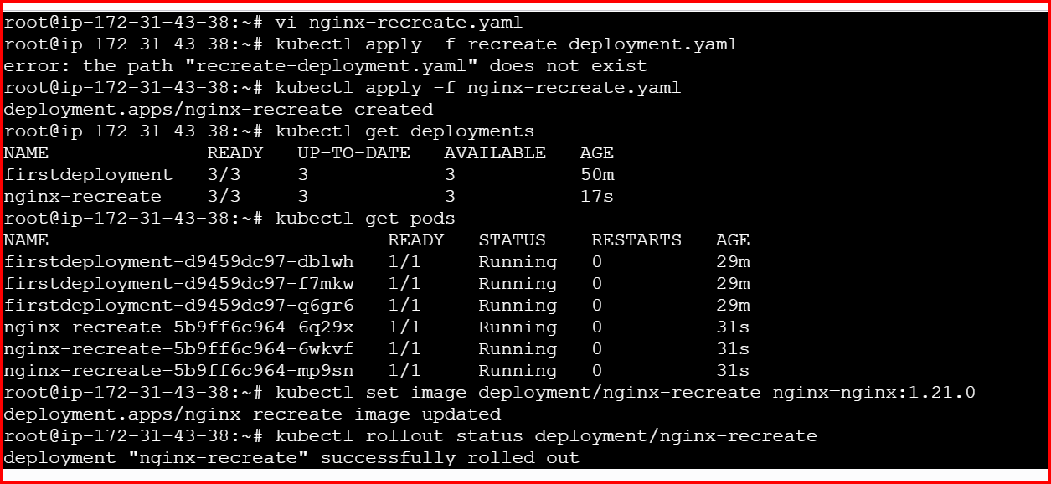

kubectl get deployments
kubectl get pods
kubectl set image deployment/nginx-recreate nginx=nginx:1.21.0
kubectl set image deployment/nginx-recreate nginx=nginx:1.21.0

kubectl get pods -w cautiously monitor

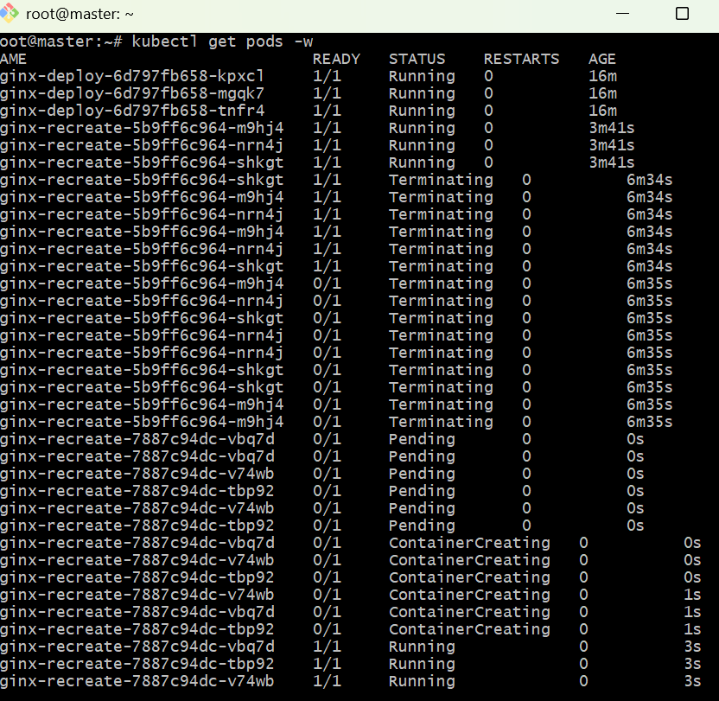

Note:
All the pods are terminated first, then new pods are getting created during this time no pods are available,

Confirm Strategy Type
kubectl describe deployment nginx-recreate | grep StrategyType

3.
Step 1: Check Current Deployment
First, confirm your current deployment details:
kubectl get deployments
Step 2: Check Current Image Version
To see which image version your deployment is using:
kubectl describe deployment nginx-recreate | grep Image
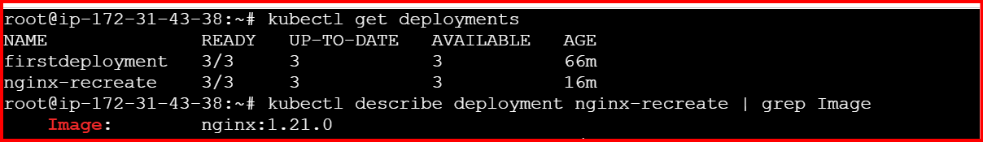
Step 3: Update the Deployment
Now, update it to a new image version (for example, nginx:1.27.0):
kubectl set image deployment/nginx-recreate nginx=nginx:1.27.0
Check rollout progress:
kubectl rollout status deployment/nginx-recreate
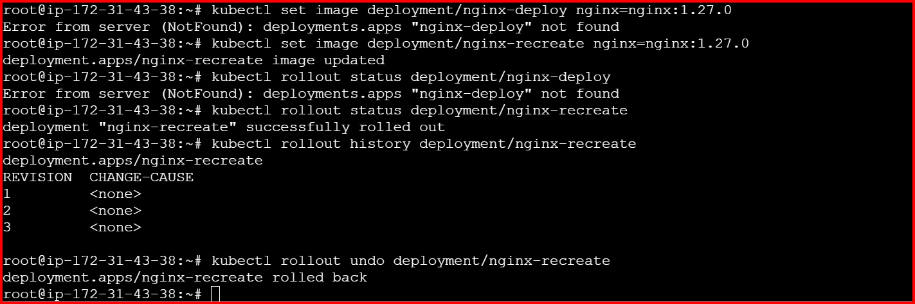

kubectl rollout history deployment/nginx-deploy
kubectl rollout undo deployment/nginx-deploy
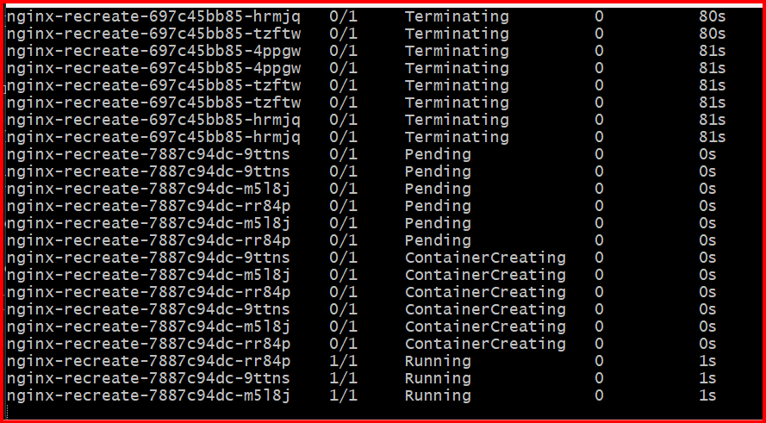

4.
Vi nginx-deployment.yaml
apiVersion: apps/v1
kind: Deployment
metadata:
name: nginx-deploy
spec:
replicas: 3
selector:
matchLabels:
app: nginx
template:
metadata:
labels:
app: nginx
spec:
containers:
- name: nginx
image: nginx:1.25
ports:
- containerPort: 80
resources:
requests:
cpu: "100m"
memory: "128Mi"
limits:
cpu: "250m"
memory: "256Mi"

kubectl apply -f nginx-deployment.yaml
kubectl apply -f nginx-deployment.yaml

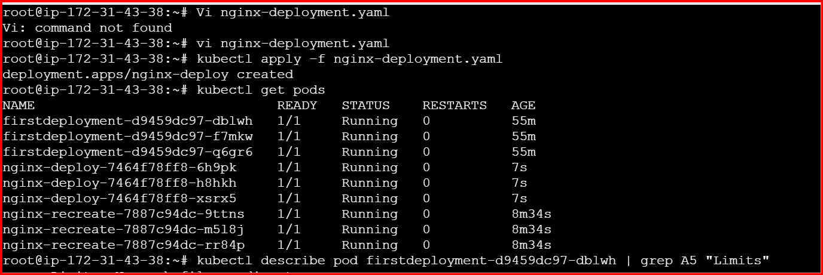

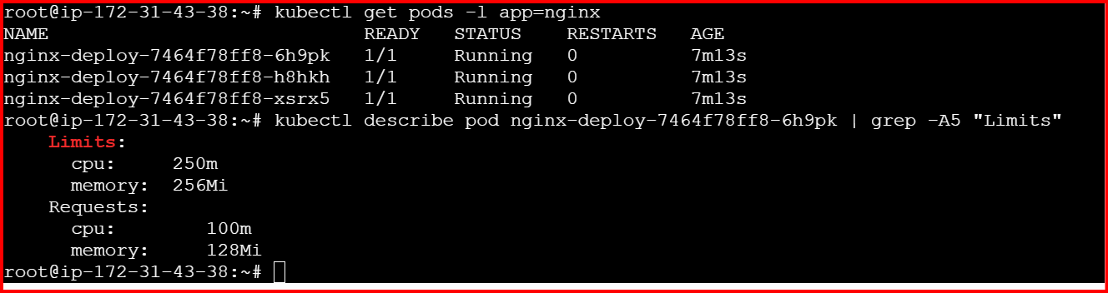

5.
Vi nginx-surge-deploy.yaml
apiVersion: apps/v1
kind: Deployment
metadata:
name: nginx-surge-deploy
spec:
replicas: 4
selector:
matchLabels:
app: nginx-surge
strategy:
type: RollingUpdate
rollingUpdate:
maxSurge: 2
maxUnavailable: 1
template:
metadata:
labels:
app: nginx-surge
spec:
containers:
- name: nginx
image: nginx:1.23
ports:
- containerPort: 80

# Apply the deployment
kubectl apply -f nginx-surge-deploy.yaml

# Check status
kubectl get deployments

# Watch rollout
kubectl rollout status deployment/nginx-surge-deploy

# List pods
kubectl get pods -l app=nginx-surge -o wide

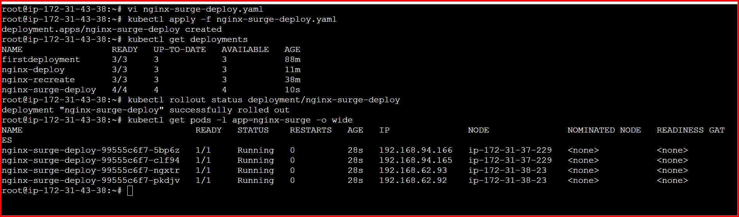

To Test Rolling Update Behavior:
Update the image to simulate a rollout:
kubectl set image deployment/nginx-surge-deploy nginx=nginx:1.24
kubectl rollout status deployment/nginx-surge-deploy

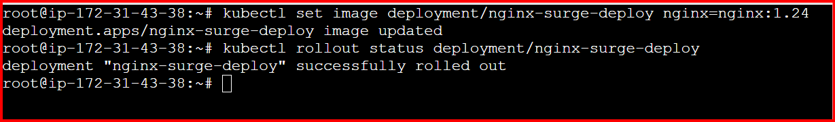

During the update, you’ll observe:
- Up to 6 pods running (4 desired + 2 surge)
- Up to 1 pod unavailable
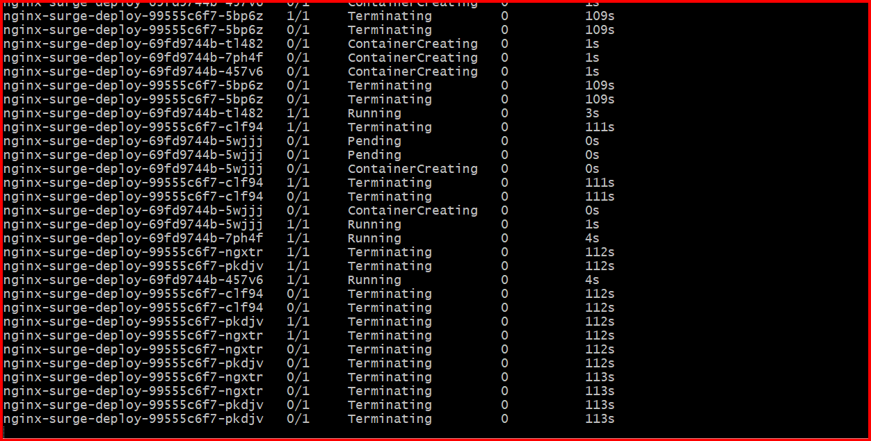
To confirm the strategy used:
kubectl describe deployment nginx-surge-deploy | grep -A3 StrategyType
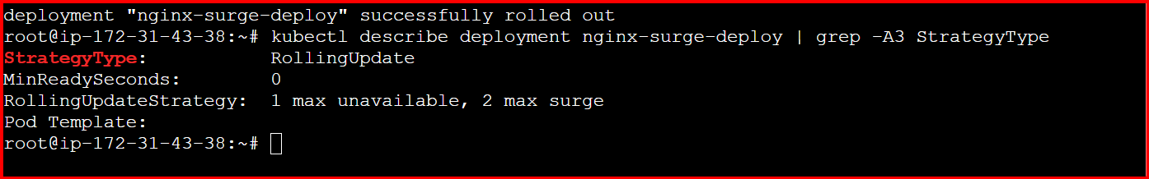

6. vi nginx-history-deploy.yaml

apiVersion: apps/v1
kind: Deployment
metadata:
name: revisionlimit-deployment
labels:
app: revision-demo
spec:
replicas: 3
revisionHistoryLimit: 2 # 👈 Only keep the last 2 revisions
selector:
matchLabels:
app: revision-demo
strategy:
type: RollingUpdate
rollingUpdate:
maxSurge: 1
maxUnavailable: 1
template:
metadata:
labels:
app: revision-demo
spec:
containers:
- name: nginx
image: nginx:1.25.0
ports:
- containerPort: 80
# Apply the deployment
kubectl apply -f nginx-history-deploy.yaml
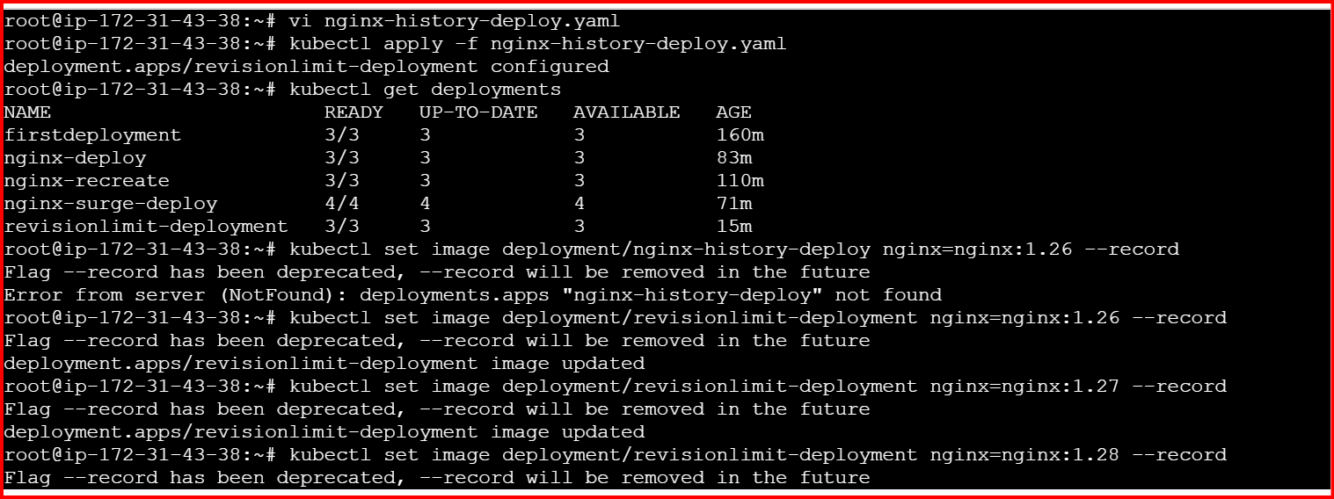

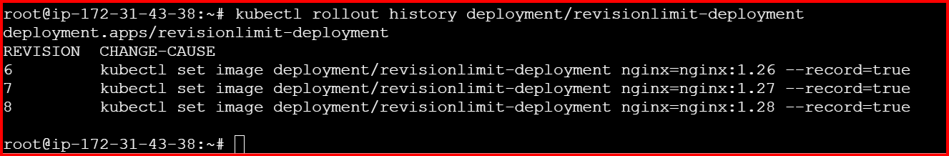

7.
vi pause.yaml
apiVersion: apps/v1
kind: Deployment
metadata:
name: pause-app
labels:
app: pause-demo
spec:
replicas: 3
revisionHistoryLimit: 2
strategy:
type: RollingUpdate
rollingUpdate:
maxSurge: 1
maxUnavailable: 1
selector:
matchLabels:
app: pause-demo
template:
metadata:
labels:
app: pause-demo
spec:
containers:
- name: nginx
image: nginx:1.27
ports:
- containerPort: 80

kubectl apply -f pause.yaml

Pause the Deployment
kubectl rollout pause deployment/pause-app

Update the Deployment (while paused)
kubectl set image deployment/pause-app nginx=nginx:1.28

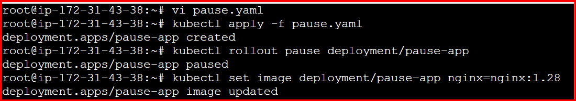

Check rollout status:
kubectl rollout status deployment/pause-app

Resume the Deployment
kubectl rollout resume deployment/pause-app
Check progress:
kubectl rollout status deployment/pause-app
kubectl get pods -l app=pause-demo

